INTRODUCTION
A modern computer consists of one or more processors, some main memory, disks, printers, a keyboard, a mouse, a display, network interfaces, and various other input/output devices. All in all, a complex system. If every application programmer had to understand how all these things work in detail, no code would ever get written. Furthermore, managing all these components and using them optimally is an exceedingly challenging job. For this reason, computers are equipped with a layer of software called the operating system, whose job is to provide user programs with a better, simpler, cleaner, model of the computer and to handle managing all the resources just mentioned. The operating system is an essential part of a computer system; it is an intermediary component between the application programs and the hardware.

HISTORY OF OPERATING SYSTEMS
Operating systems have been evolving through the years. In the following sections we will briefly look at a few of the highlights. Since operating systems have historically been closely tied to the architecture of the computers on which they run, we will look at successive generations of computers to see what their operating systems were like. The first true digital computer was designed by the English mathematician Charles Babbage (1792-1871). Although Babbage spent most of his life and fortune trying to build his "analytical engine," he never got it working properly because it was purely mechanical, and the technology of his day could not produce the required wheels, gears, and cogs to the high precision that he needed. Needless to say, the analytical engine did not have an operating system. As an interesting historical aside, Babbage realized that he would need software for his analytical engine, so he hired a young woman named Ada Lovelace, who was the daughter of the famed British poet Lord Byron, as the world's first programmer.

The First Generation (1945-55) Vacuum Tubes
After Babbage's unsuccessful efforts, little progress was made in constructing digital computers until World War II, which stimulated an explosion of activity. Prof. John Atanasoff and his graduate student Clifford Berry built what is now regarded as the first functioning digital computer at Iowa State University. It used 300 vacuum tubes. At about the same time, Konrad Zuse in Berlin built the Z3 computer out of relays. Some were binary, some used vacuum tubes, some were programmable, but all were very primitive and took seconds to perform even the simplest calculation. In these early days, a single group of people (usually engineers) designed, built, programmed, operated, and maintained each machine. All programming was done in absolute machine language, or even worse yet, by wiring up electrical circuits by connecting thousands of cables to plug boards to control the machine's basic functions. Programming languages were unknown (even assembly language was unknown). Operating systems were unheard of.

The Second Generation (1955-65) Transistors and Batch Systems
The introduction of the transistor in the mid-1950s changed the picture radically. Computers became reliable enough that they could be manufactured and sold to paying customers with the expectation that they would continue to function long enough to get some useful work done. For the first time, there was a clear separation between designers, builders, operators, programmers, and maintenance personnel. These machines, now called mainframes, were locked away in specially air conditioned computer rooms, with staffs of professional operators to run them.
Only large corporations or major government agencies or universities could afford them. To run a job (i.e., a program or set of programs), a programmer would first write the program on paper (in FORTRAN or assembler), then punch it on cards. He would then bring the card deck down to the input room and hand it to one of the operators and wait until the output was ready.
When the computer finished whatever job it was currently running, an operator would go over to the printer and tear off the output and carry it over to the output room, so that the programmer could collect it later. Then he would take one of the card decks that had been brought from the input room and read it in. If the FORTRAN compiler was needed, the operator would have to get it from a file cabinet and read it in. Much computer time was wasted while operators were walking around the machine room. The solution generally adopted was the batch system. The idea behind it was to collect a tray full of jobs in the input room and then read them onto a magnetic tape using a small (relatively) inexpensive computer, such as the IBM 1401,
Other, much more expensive machines, such as the IBM 7094, were used for the real computing. After about an hour of collecting a batch of jobs, the cards were read onto a magnetic tape, which was carried into the machine room, where it was mounted on a tape drive. The operator then loaded a special program (the ancestor of today's operating system), which read the first job from tape and ran it. The output was written onto a second tape, instead of being printed. After each job finished, the operating system automatically read the next job from the tape and began running it. When the whole batch was done, the operator removed the input and output tapes, replaced the input tape with the next batch, and brought the output tape to a 1401 for printing offline (i.e., not connected to the main computer).

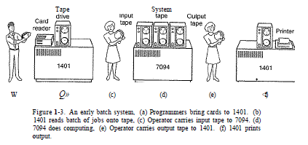
The Third Generation (1965-1980) ICs and Multiprogramming
By the early 1960s, most computer manufacturers had two distinct, incompatible, product lines. On the one hand there were the word-oriented, large-scale scientific computers, such as the 7094, which were used for numerical calculations in science and engineering. On the other hand, there were the character oriented, commercial computers, such as the 1401, which were widely used for tape sorting and printing by banks and insurance companies. With the introduction of the IBM System/360, which used ICs (Integrated Circuits), IBM combined these two machine types. One of the many innovations was multiprogramming, the ability to have several programs in memory at once, each in its own memory partition. While one job was waiting for I/O to complete, another job could be using the CPU. Special hardware kept one program from interfering with another. Although third-generation operating systems were well suited for big scientific calculations and massive commercial data processing runs, they were still basically batch systems with turnaround times of an hour. Programming is difficult if a misplaced comma wastes an hour. This desire of many programmers for quick response time paved the way for timesharing, a variant of multiprogramming, in which each user has an online terminal.

The Fourth Generation (1980-Present) Personal Computers

With the development of LSI (Large Scale Integration) circuits, chips containing thousands of transistors on a square centimeter of silicon, the age of the personal computer dawned. Where the mini computer made it possible for a department in a company or university to have its own computer, the microprocessor chip made it possible for a single individual to have his or her own personal computer. Earlier operating systems like CP/M, MS-DOS, and other operating systems for early microcomputers were all based on users typing in commands from the keyboard. That eventually changed due to research done by Doug Engelbart at Stanford Research Institute in the
1960s. Engelbart invented the GUI Graphical User Interface, complete with windows, icons, menus, and mouse. These ideas were adopted by researchers at Xerox PARC and incorporated into machines they built. An interesting development that began taking place during the mid-1980s is the growth of networks of personal computers running network operating systems and distributed operating systems. In a network operating system, the users are aware of the existence of multiple computers and can log in to remote machines and copy files from one machine to another.
Each machine runs its own local operating system and has its own local user (or users).
Network operating systems are not fundamentally different from single-processor operating systems. They obviously need a network interface controller and some low-level software to drive it, as well as programs to achieve remote login and remote file access, but these additions do not change the essential structure of the operating system. A distributed operating system, in contrast, is one that appears to its users as a traditional uniprocessor system, even though it is actually composed of multiple processors. The users should not be aware of where their programs are being run or where their files are located; that should all be handled automatically and efficiently by the operating system. True distributed operating systems require more than just adding a little code to a uniprocessor operating system, because distributed and centralized systems differ in certain critical ways. Distributed systems, for example, often allow applications to run on several processors at the same time, thus requiring more complex processor scheduling algorithms in order to optimize the amount of parallelism.

OPERATING SYSTEM OBJECTIVES AND FUNCTIONS

An OS is a program that controls the execution of application programs and acts as an interface between applications and the computer hardware. An OS can be thought of as having 3 objectives:
- Convenience: An OS makes a computer more convenient to use.

- Efficiency: An OS allows the computer system resources to be used in an efficient manner.
- Ability to evolve: An OS should be constructed in such a way as to permit the effective development, testing and introduction of new system functions without interfering with service.

THE OPERATING SYSTEM AS A USER/COMPUTER INTERFACE

The hardware and software used in providing applications to a user can be viewed in a layered or hierarchical fashion as shown below:

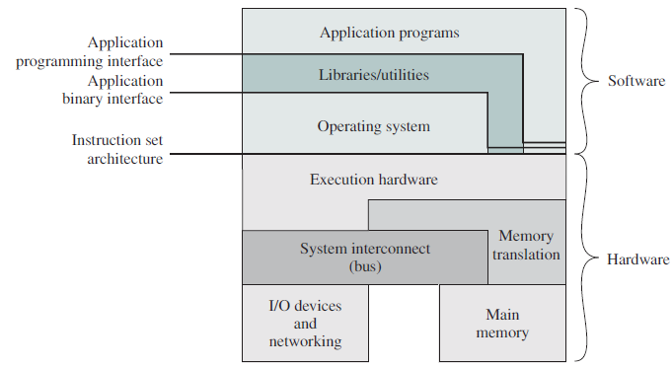

The end user is generally not concerned with the details of computer hardware but rather views a computer system in terms of a set of applications. An application can be expressed in a programming language. If one were to develop an application program as a set of machine instructions that is completely responsible for controlling the computer hardware, one would be faced with an overwhelming complex undertaking. To ease this chore, a set of system programs called utilities/library programs are provided which implement frequently used functions that assist in program creation, the management of files and the control of I/O devices. A programmer makes use of these facilities in developing an application, and the application while running, will invoke utilities to perform certain functions. The most important collection of system programs comprises the OS. The OS mask the details of the hardware from the programs and provides the programmer with a convenient interface for using the system. The OS typically provides services in the following areas:
- Program Development: The OS provides a variety of facilities and services e.g. editors and debuggers to assist the programmer in creating programs. Typically, these services are in the form of utility programs that while not strictly part of the core of the OS, are supplied with the OS and are referred to as application program development tools.

- Program Execution: A number of steps need to be performed to execute a program such as instructions and data being loaded into main memory, I/O devices and files being initialized e.t.c. The OS handles these scheduling duties for the users.

- Controlled Access To Files: For file access, the OS must reflect a detailed understanding of not only the nature of the I/O device but also the structure of the data contained in the files on the storage medium. In the case of a system with multiple users, the OS may provide protection mechanisms to control access to the files.

- System Access: For shared or public systems, the OS controls access to the system as a whole and to specific system resources. The access function must provide protection of resources and data from unauthorized users and must resolve conflicts for resource contention.

- Accounting: A good OS will collect usage statistics for various resources and monitor performance parameters such as response time. On any system, this information is useful in anticipating the need for future enhancements and in tuning the system to improve performance. On a multiuser system, the information can be used for billing purposes.

THE OPERATING SYSTEM AS A RESOURCE MANAGER

A computer is a set of resources for the movement, storage and processing of data and for the control of those functions. The OS is responsible for managing these resources. The OS’s control of these resources is exercised in a curious way. Normally, we think of a control mechanism as something external to that which is controlled, or at least as something that is distinct and separate part of that which is controlled. This is not the case with the OS which as a control mechanism is unusual in 2 aspects:

- The OS functions in the same way as ordinary computer software i.e. it is a program or set of programs executed by the processor.

- The OS frequently relinquishes control and must depend on the processor to allow it regain control.

Like other computer programs, the OS provides instructions for the processor. The key difference is in the intent of the program. The OS directs the processor in the use of other system resources and in the timing of its execution of other programs. But in order for the processor to do any of these things, it must cease executing the OS program and execute other programs. Thus, the OS relinquishes control for the processor to do some useful work and then resumes control long enough to prepare the processor to do the next piece of work. The processor itself is a resource, and the OS must determine how much processor time is devoted to the execution of a particular user program. In the case of a multiple-processor system, this decision must span all of the processors.

EASE OF EVOLUTION OF AN OPERATING SYSTEM

A major OS will evolve over time for a number of reasons:

- Hardware upgrades plus new types of hardware: For example, early versions of UNIX and Macintosh OS did not employ a paging mechanism because they were run on processors without paging hardware. Subsequent versions of these operating systems were modified to exploit paging capabilities.

- New services: In response to user demand or in response to the needs of system managers, the OS managers, the OS expands to offer new services.

- Fixes: Any OS has faults. These are discovered over the course of time and fixes are made. Of course, the fix may introduce new faults.

SOFTWARE COMPONENTS
A program is a sequence of instructions that enables a computer to execute a specific task. Before a program executes, it has to be translated from its original text form (source program) into a machine language program. The program then needs to be linked and loaded into memory.
The software components are the collection of programs that execute in the computer. These programs perform computations and control, manage, and carry out other important tasks. There are two general types of software components:

- System software
- Application software

System software: is the set of programs that control the activities and functions of the various hardware components, programming tools and abstractions, and other utilities to monitor the state of the computer system.

Application software: are the user programs and consists of those programs that solve specific problems for the users and execute under the control of the operating system. Application programs are developed by individuals and organizations for solving specific problems.

OPERATING SYSTEM INTERFACES

Users and application programmers can communicate with an operating system through its interfaces. There are three general levels of interfaces provided by an operating system:

- Graphical user interface (GUI)
- Command line interpreter (also called the shell)
- System-call interface

The highest level is the graphical user interface (GUI), which allows I/O interaction with a user through intuitive icons, menus, and other graphical objects. With these objects, the user interacts with the operating system in a relatively easy and convenient manner for example, using the click of a mouse to select an option or command. The most common GUI examples are the Windows desktop and the X-Window in Unix. The user at this level is completely separated from any intrinsic detail about the underlying system.

The second level of interface, the command line interpreter, or shell, is a text oriented interface. Advanced users and application programmers will normally directly communicate with the operating system at this level. In general, the GUI and the shell are at the same level in the structure of an operating system.

The third level, the system-call interface, is used by the application programs to request the various services provided by the operating system by invoking or calling system functions.

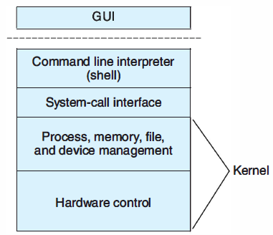

MULTI-LEVEL VIEWS OF AN OPERATING SYSTEM

The overall structure of an operating system can be more easily studied by dividing it into the various software components and using a top-down (layered) approach. This division includes the separation of the different interface levels, as previously discussed, and the additional components of the operating system. The higher the level of the layer, the simpler the interaction with the system. The top layer provides the easiest interface to the human operators and to users interacting with the system. Any layer uses the services or functions provided by the next lower layer. For a more clear understanding of the complexities of how the various services are provided, two abstract views of the OS are presented: the external view and the internal view.

EXTERNAL VIEW OF AN OPERATING SYSTEM

The external view of an operating system is the set of interfaces discussed previously. These are sometimes referred to as the abstract views. Users of a computer system directly or indirectly communicate with the operating system in order to request and receive some type of service provided by the operating system. Users and application programs view the computer system at the higher level(s) of the operating system interface. The low-level OS structures (internal view) and the hardware details are hidden behind the OS interface. One of the main principles applied in the design of the external view concept is simplicity. The system interfaces hide the details of how the underlying (lower-level) machinery operates. The abstraction provided by the OS interfaces gives users and application programs the appearance of a simpler machine.

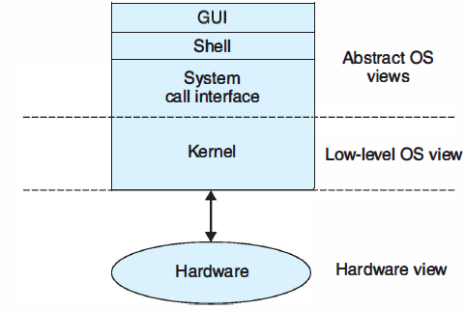

INTERNAL VIEW OF AN OPERATING SYSTEM

The system services interface (or the system call interface) separates the kernel from the application layer. Located above the hardware, the kernel is the core and the most critical part of the operating system and needs to be always resident in memory. A detailed knowledge about the different components of the operating system, including these lower-level components, corresponds to an internal view of the system. The most important functional components of the operating system are as follows:

- Process manager
- Memory manager
- Resource manager
- File manager
- Device manager

These components are actually modules of the operating system and are strongly related.

PROCESS MANAGER: The process manager can be considered the most important component of the operating system. It carries out several services such as creating, suspending (blocking), executing, terminating, and destroying processes. With multiprogramming, several active processes are stored and kept in memory at the same time. If there is only one CPU in the system, then only one process can be in execution at a given time; the other processes are waiting for CPU service. The decision regarding which process to execute next is taken by the scheduler. The dispatcher allocates the CPU to a process and deallocates the CPU from another process. This switching of the CPU from one process to another process is called context switching.

MEMORY MANAGER: The memory manager controls the allocation and deallocation of memory. It imposes certain policies and mechanisms for memory management. This component also includes policies and mechanisms for memory protection. Relevant memory management schemes are paging, segmentation, and virtual memory.

RESOURCE MANAGER: The resource manager facilitates the allocation and deallocation of resources to the requesting processes. Functions of this component include the maintenance of resource tables with information such as the number of resources of each type that are available and the number of resources of each type that have been allocated to specific processes. The access mode for the various resources is another type of function.

FILE MANAGER: The file manager allows users and processes to create and delete files and directories. In most modern operating systems, files are associated with mass storage devices such as magnetic tapes and disks. Data can be read and/or written to a file using functions such as open file, read data from file, write data to file, and close file.

DEVICE MANAGER: For the various devices in the computer system, the device manager provides an appropriate level of abstraction to handle system devices. For every device type, a device driver program is included in the OS. The device manager operates in combination with the resource manager and file manager.

PROCESSES AND THREADS

A process is a program in execution, ready to execute, or one that has executed partially and is waiting for other services in the computer system. In simpler terms, a process is an instantiation of a program, or an execution instance of a program. A process is a dynamic entity in the system because it exhibits behavior (state changes), and is capable of carrying out some (computational) activity, whereas a program is a static entity. This is similar to the difference that exists between a class (a static entity) and an object (a dynamic entity) in object-oriented programming. Two basic types of processes are system processes and user processes. System processes execute operating system services, user processes execute application programs. The operating system (OS) manages the system hardware and provides various computing services for the processes. The OS hides from the user processes all details of the operation of the underlying hardware and how the various services are implemented.

A typical and simplified scenario of how the OS manages the various processes can be described as follows: processes request CPU and I/O services at various times and usually wait for these services. The OS maintains a waiting line or queue of processes for every one of these services. At some time instance, the process will be in a queue waiting for CPU service. At some other instance, the process will be in a different queue waiting for I/O service. When the process completes all service requests, it terminates and exits the system.
Process management is one of the major functions of the operating system; it involves creating processes and controlling their execution. In most operating systems, several processes are stored in memory at the same time and the OS manages the sharing of one or more processors (CPUs) and other resources among the various processes. This technique implemented in the operating system is called multiprogramming. One of the requirements of multiprogramming is that the OS must allocate the CPUs and other system devices to the various processes in such a way that the CPUs and other devices are maintained busy for the longest total time interval possible, thus minimizing the idle time of these devices. If there is only one CPU in the computer system, then only one process can be in execution at any given time. Some other processes are ready and waiting for CPU service while other processes are waiting or receiving I/ 0 service. For every program that needs execution in the system, a process is created and is allocated resources (including some amount of memory). The address space of a process is the set of memory addresses that it can reference.

